A Life Changing Life

Campaign supporter kit

For employers

Introduction

The Australian Government’s A Life Changing Life campaign aims to generate interest in the care and support sector, which includes aged care, disability and veterans’ support. We will prompt students, job searchers and professionals who have the qualities and skills the sector needs to take action and consider a job or career in care and support.

This kit includes information and resources that will help attract people with the qualities and skills the care and support sector needs, helping you find great new talent as we drive more people to consider the sector.

This toolkit is a practical guide for employers. It is designed to help you share the campaign.

About the campaign

The Australian Government’s A Life Changing Life was developed by the Department of Social Services, in collaboration with the Department of Health and Department of Veterans’ Affairs.

It is informed by research with potential workers, current care and support workers, employers and stakeholders, and people with disability, older people and veterans.

The growth of the National Disability Insurance Scheme (NDIS) and our ageing population means the care and support sector will grow quickly over the coming years. Through the campaign and a range of additional workforce and sector initiatives, our goal is to attract around 140,000 people to the care and support sector by 2024.

Research shows that a key reason people work in the sector is the warm and mutually beneficial relationships they develop with the people they support. A Life Changing Life shares the stories of these rewarding relationships to boost knowledge about the diversity and value of the work, and disrupt outdated perceptions.

The campaign features real care and support workers, and the people they support – not actors.

Potential workers (the campaign’s primary audiences) include:

- tertiary students studying related fields
- young people who are looking for meaningful work
- job seekers with an interest in this sector
- people returning to the workforce, including carers
- professionals who could transfer their skills across to the sector
- recent arrivals to Australia
- Aboriginal and Torres Strait Islander people
- people from culturally and linguistically diverse (CALD) backgrounds.
The campaign includes advertising (television, outdoor, digital), public relations, social media, and a strong focus on encouraging stakeholders, employers, existing workers, influential people and communities to share the campaign with target audiences.

The campaign hub is careandsupportjobs.gov.au. It features information about the roles available, pathways into the sector, skills and training, lots of case studies and links to job search services.

How you can help

Every action you take to support the campaign, no matter how small, can help to change the lives of people with disability, older people and our veterans.

Here are some ideas for sharing A Life Changing Life:

- Share the campaign’s website, messages and materials with your professional and personal networks.
- Encourage staff and colleagues to share the campaign’s messages and materials with their own networks, and let them know they are welcome to share their own positive stories.
- Publish a description about the campaign on your organisation’s website using the key messages in this kit, and include a link to the campaign website.
- Review your organisation’s website and other assets, and identify opportunities to reflect the campaign’s key messages.
- Include the enclosed editorial, and link to campaign case studies in your newsletters, publications and other communication channels.
- Follow the campaign’s Facebook page (@CareAndSupportAus) to read and share the stories of people who work in the care and support sector and the people they support.
- Publish messages through your professional social media channels. Use any or all of the included hashtags for your social media posts, attach a campaign image or link to the videos and the campaign website.
Everything you need to share the campaign is included in this pack.

How the campaign can help you

A Life Changing Life will shine a spotlight on the care and support sector as an attractive, rewarding option for a job or career. As a result, there will be a whole lot of passionate and motivated people considering working in the sector. We encourage you to make the most of the national campaign to help you recruit for your organisation.

Whether you are recruiting now, or will be looking to recruit in the future, the campaign will help you attract people with the right skills and qualities. These materials can last beyond the national campaign – you can use them whenever you need to recruit.

Here are some ideas on how to use the campaign to support your recruitment:

- Use the key messages in job advertisements, position descriptions, presentations, speeches, and information for your contact centre staff.
- Hold a presentation for potential workers, students, people considering a career change, job searchers, or the general community in your area.
- Hire the A Life Changing Life mobile exhibition pack for your event or public space.
- Hold a digital or in-person event showcasing the campaign videos and case studies for your team members, and ask them to share what they enjoy about working in the care and support sector.
- Encourage your staff to share the campaign videos with friends and family on their own social media channels.
- Encourage your staff to send a digital postcard via text message, email or social media to someone who could be a good fit for your organisation. Alternatively, share the link to the campaign website where they can search for jobs and find out more.

You can find additional information and strategies for employers on
careandsupportjobs.gov.au/resources/employer-resources

Campaign resources

Share the campaign on your website

General website copy

Including a news item about A Life Changing Life on your website will help engage candidates who have seen the national advertising campaign.

Description

Are you ready for a life changing life? The care and support sector is now hiring, with rewarding jobs available in aged care, disability and veterans’ support. With opportunities to work flexible hours, and to learn and grow across a variety of roles, you will change lives – as well as your own.
Visit careandsupportjobs.gov.au.

Longer description

Are you ready for a life changing life? The care and support sector is now hiring, with rewarding and meaningful jobs available in aged care, disability and veterans’ support. With opportunities to work flexible hours, and to learn and grow across a variety of roles, you will change lives – as well as your own. Visit careandsupportjobs.gov.au for links to job search services, personal stories, and information about the types of roles, entry requirements, training and development opportunities, pathways into the work, and jobs and careers.

Career / Vacancies Page

We encourage you to use the campaign’s key messages on your careers/vacancies page so people who are looking for jobs in the care and support sector know they are in the right place.

Description

Are you ready for a life changing life in the care and support sector? We are now hiring.

With a job at [insert organisation name], you’ll have opportunities to work flexible hours, and learn and grow across a variety of roles. You will change lives – as well as your own.

Longer description

Are you ready for a life changing life in the care and support sector? We are now hiring.

With a job at [insert organisation name], you’ll have opportunities to work flexible hours, and learn and grow across a variety of roles. You will change lives – as well as your own.

We are looking for people with diverse skills and backgrounds who want to make a difference for people. We offer on-the-job training, mentoring, peer support, and you’ll work with clients who are a good match
for you.

Visit careandsupportjobs.gov.au to find out more about meaningful and rewarding work in the care and support sector. See our open positions [link to where your jobs are advertised].

Accompanying image

This image is available to download from the A Life Changing Life Resources Hub (bit.ly/ALCLprimaryresourcehub). Ensure the image clicks through to careandsupportjobs.gov.au.
Content for your e-newsletters and publications

We encourage you to include editorial and case studies in your newsletters, publications and other communication channels. Use can use the example below, or the key messages in this toolkit to develop your own content.

You may like to use the key messages in this toolkit to develop your own news items about the A Life Changing Life campaign, and the jobs and careers available in the care and support sector (aged care, disability and veterans’ support).

Visit the A Life Changing Life Resources Hub (bit.ly/ALCLemployerresourcehub) to download images and videos for your communication channels.

Newsletter Content

You can use this template newsletter copy below or tailor it to suit your needs.

We need more people like you!

Here at [insert your organisation’s name], we can only offer high quality support to our clients because of our committed, compassionate staff who make a difference every day. The Australian Government’s campaign, A Life Changing Life, aims to raise awareness of employment opportunities in the care and support sector.

It highlights a key part of why we do what we do – the warm and mutually beneficial relationships we have with the people we support. It shares the real stories of workers and the people they support, and shows the diversity, value and impact of our work. You can find out more and watch the campaign videos at careandsupport.jobs.gov.au.

The campaign runs from 15 August, meaning many people will be thinking about care and support roles. It is a fantastic opportunity to recruit the new staff we need. We are looking for job seekers, people returning to the workforce and people from diverse backgrounds – anyone interested in a life changing life. Do you know someone who would be a great fit?

You could:
- Share current vacancies within [insert your organisation’s name] with friends or family and encourage them to apply
- Send a digital postcard to someone you think would be a good fit
- Use your social media networks to tell people how much you enjoy your role in the care and support sector
- Follow [insert your organisation’s name] social media channels and ‘Like’ and ‘Share’ our posts promoting A Life Changing Life.

Real stories

We have developed a range of real-life stories to showcase the many reasons people join the care and support sector, and the number one reason they get so much out of it – the warm and mutually beneficial relationships they develop.

Below is a snapshot of the featured content films, you’ll find more at
careandsupportjobs.gov.au/resources/stories

Caroline, Jake and Darcy

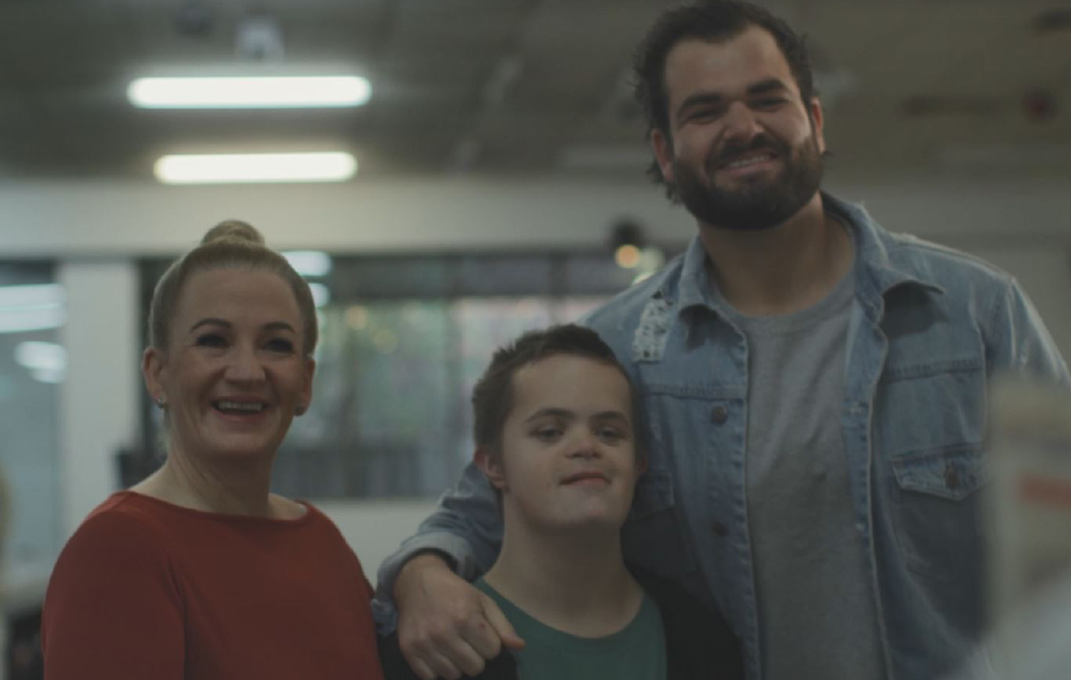

Caroline has been supporting Darcy for around five years. They enjoy going ten pin bowling, playing board games, listening to music and dancing together. Darcy has changed the lives of Caroline and Jake for the better, where they appreciate the little things in life that can often be taken for granted.

Caroline and Jake - disability support workers

Mother and son Caroline and Jake are disability support workers for Darcy. Caroline introduced Jake to the care and support sector and Jake says he’s never looked back.

Mandy and Elizabeth

While working together, Mandy and Elizabeth have become firm friends. Mandy helps Elizabeth stay independent in her home, while Elizabeth is always happy to provide advice and share a laugh and a cup of tea.

Mandy - aged care worker

Mandy moved from banking into the care and support sector because she wanted a job where she could be of service to people. She explains why she enjoys working in aged care and how it has changed her life.

Freya and Michelle

Freya is Michelle’s disability support worker and best friend. They have built an amazing professional and personal relationship, enriching each other’s lives. They share a love for shoes.

Freya – disability support worker

Freya joined the care and support sector in search for a job where she can build amazing relationships, enjoy rewarding and meaningful work, and feel proud of what she’s achieved on a daily basis.

Keep checking the stories page as more real-life stories will be added. careandsupportjobs.gov.au/resources/stories

Digital Postcard

Download a digital postcard to send via text message, email or social media to someone who would be a good fit for the sector.

The postcard is available to download from the A Life Changing Life Resources Hub
(bit.ly/ALCLemployerresourcehub).

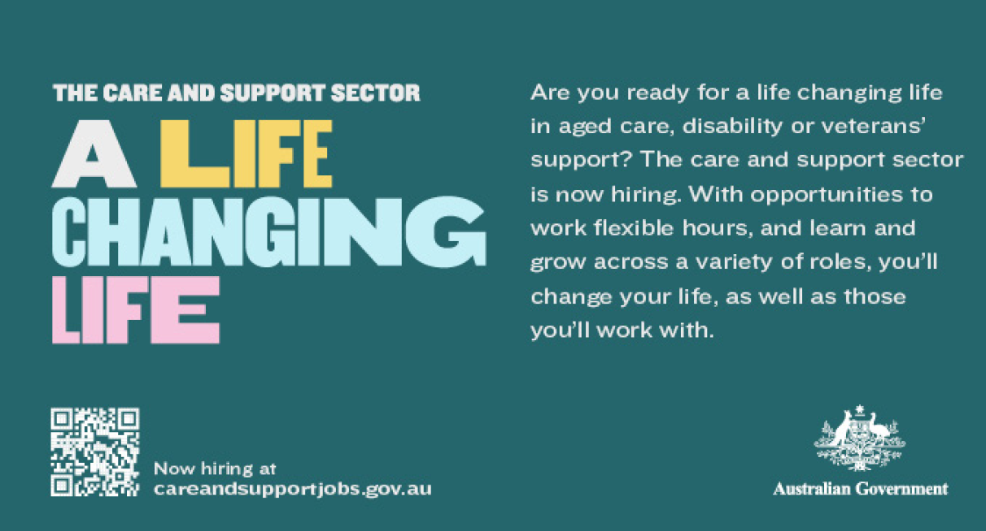

Content for your social media

Join us on Facebook

The campaign’s Facebook page @CareAndSupportAus is a community dedicated to sharing the stories of people who work in the care and support sector and the people they support, and highlighting the diversity of the work and people in the sector.

We invite you to follow the page, and to share posts with your own social media communities.

Publish your own posts

Here are some suggested posts you may like to publish on your own social media channels.

We encourage you to:
- Tailor these posts to suit your needs – for example, mention your organisation; current roles you are advertising; adapt the language to suit your audience; or shorten content for Twitter.
- Use any or all of the included hashtags for your social media posts.
- Attach a campaign image or video to your post.
- Link to the campaign website careandsupportjobs.gov.au.
Images and videos for social media can be downloaded from the A Life Changing Life Resources Hub (bit.ly/ALCLemployerresourcehub).

Real-life stories are available at careandsupportjobs.gov.au/resources/stories

Social media post for aged care sector

For rewarding opportunities across aged care, and a chance to transfer your skills, visit careandsupportjobs.gov.au #ALifeChangingLife #CareAndSupportJobs #CareAndSupportChangesLives

Social media post for NDIS sector

As a care and support worker in the NDIS, one day you could be [insert activity e.g. going to the movies], the next you could be [insert different activity e.g. visiting someone in their home]. For rewarding work that makes a difference, visit careandsupportjobs.gov.au. #ALifeChangingLife #CareAndSupportJobs #CareAndSupportChangesLives

Social media post for Veterans’ care sector

To support returning veterans and their families while learning through on-the-job training, consider a job or career in the dynamic care and support sector. Visit careandsupportjobs.gov.au. #ALifeChangingLife #CareAndSupportJobs #CareAndSupportChangesLives

Messages that can be adapted for all audiences and sectors

Work in the care and support sector makes a difference. To find out more about the warm and rewarding relationships you make with clients who are a good match for you, visit careandsupportjobs.gov.au. #ALifeChangingLife #CareAndSupportJobs #CareAndSupportChangesLives

The care and support sector is a dynamic growth industry with a wide range of roles and opportunities for people with diverse skills, experiences and backgrounds. To find out more, visit careandsupportjobs.gov.au. #ALifeChangingLife #CareandSupportJobs #CareandSupportChangesLives

We are proud to be part of the care and support sector – it’s meaningful and rewarding work that makes a difference. Visit careandsupportjobs.gov.au to find out more. #ALifeChangingLife #CareAndSupportJobs #CareAndSupportChangesLives

Do you know someone who would make a great care and support worker? Tag them below! #ALifeChangingLife #CareAndSupportJobs #CareAndSupportChangesLives

Messages for organisations currently recruiting

We are hiring. For rewarding work that makes a difference, visit careandsupportjobs.gov.au. #ALifeChangingLife #CareAndSupportJobs #CareAndSupportChangesLives

Are you ready for a Life Changing Life? With opportunities to work flexible hours, and learn and grow across a variety of roles, you will change lives – as well as your own. For work that makes a difference, visit careandsupportjobs.gov.au. #ALifeChangingLife #CareAndSupportJobs #CareAndSupportChangesLives

Presentation template

There may be opportunities for you to present to potential workers, students (at schools, universities, TAFEs or open days), people considering a career change, job searchers or the general community.

The A Life Changing Life PowerPoint presentation template can help make this activity easy. You can tailor the presentation to suit your needs. It includes talking points, and embedded campaign videos and images. You may also like to use the key messages in this toolkit.

The presentation template is available to download from the A Life Changing Life Resources Hub (bit.ly/ALCLemployerresourcehub).

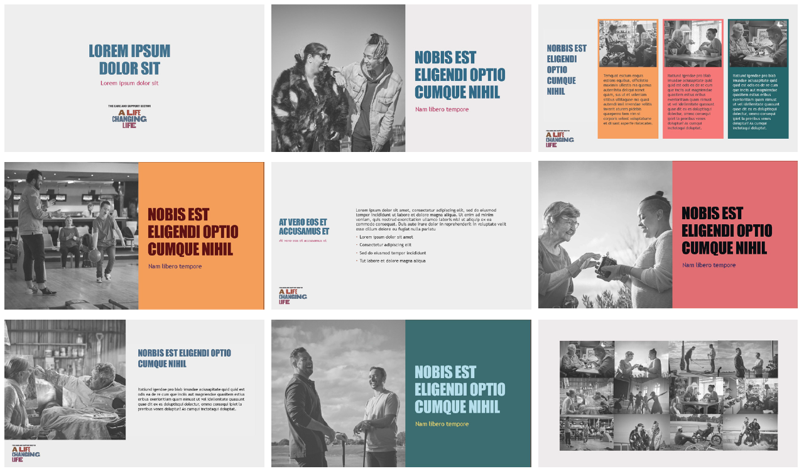
Mobile exhibition pack for events and public spaces

You can request an A Life Changing Life mobile exhibition pack for:
- An event, expo or conference
- Employee induction or training
- Employer event e.g. breakfast seminar
- Student common areas
- Public spaces e.g. library, foyer, orientation week or shopping centre.
The A Life Changing Life mobile exhibition promotes the campaign, and shares the stories of care and support workers and the people they support.

The mobile exhibition pack includes:

- Exhibition stands
- Pull-up banners
- Video image loop
- Digital background (for virtual meetings/conferences)
- Posters
- Postcard – digital or printed
- Presentation template
- Branded pens.
The exhibition pack is easy to set up and pack down. Digital assets are included on a USB.

More information and to book

We encourage you to book a pack well in advance.

To discuss your needs, contact careandsupportworkforce@dss.gov.au

You can also download posters, a presentation template and a branded backdrop for your webinar/ web chat from the A Life Changing Life Resources Hub (bit.ly/ALCLemployerresourcehub).

Key messages

You can use these key messages to support your communications with people about the A Life Changing Life campaign, and the jobs and careers available in the care and support sector (aged care, disability and veterans’ support).

Communications may include presentations, speeches, job advertisements, position descriptions, and information for contact centre staff.

Main messages

- The care and support sector is now hiring.
- With a job in aged care, disability or veterans’ support, you will learn, grow and change lives.
- Are you ready for a life changing life in aged care, disability or veterans’ support? The care and support sector is now hiring. With opportunities to work flexible hours, and learn and grow across a variety of roles, you will change lives – as well as your own.
- There are job and career opportunities across Australia for people with diverse skills and backgrounds who want to make a difference for people with disability, older people and our veterans.
- The care and support sector is a dynamic, growing industry with a wide range of roles and opportunities for people with diverse skills, experiences and backgrounds.
- Care and support roles are as diverse as the people and communities we work with.
- You will learn and grow with on-the-job training, mentoring, peer support, and clients who are a good match for you.
- Whether you want to build a career or transfer your skills and experience, are looking for work while you study, or would like flexible work that’s also interesting and meaningful – the care and support sector might have what you’re looking for.
- For meaningful and rewarding work that makes a difference, visit careandsupportjobs.gov.au.

Additional messages

About the campaign

- The Australian Government’s A Life Changing Life campaign aims to raise awareness of employment opportunities in the care and support sector, and encourage consideration and take-up among potential workers.
- Over the next few years, our goal is to attract around 140,000 people to the care and support sector.
- A Life Changing Life showcases a key reason why people work in the care and support sector – the warm and mutually beneficial relationships they develop with the people they support.
- A Life Changing Life shares the stories of care and support workers and the people they support, and shows the diversity, value and impact of the work.
- A Life Changing Life aims to reach students, young people looking for meaningful work, professionals looking to transfer their skills into the sector, and people who bring lived experience to support a diverse range of people.
- Visit careandsupportjobs.gov.au for links to job search services, personal stories, employer resources, and information about the types of roles, entry requirements, training and development opportunities, pathways into the work, and jobs and careers.
For students

- The care and support sector is now hiring. With a job in aged care, disability or veterans’ support, you will find career pathways, and work flexible hours while you learn.
- Need a job with flexible hours? The care and support sector is now hiring. Visit careandsupportjobs.gov.au.
- Working in the care and support sector while you learn gives you practical, hands-on experience that will give you the edge when you graduate.
- Graduates are in demand for roles across the care and support sector, including aged care, disability and veterans’ support.
For job searchers

- The care and support sector is now hiring. A variety of roles are available in aged care, disability or veterans’ support, and you’ll learn and grow with on-the-job training.
- Would you like a job that helps you to learn and grow with on-the-job training? The care and support sector is now hiring. Visit careandsupportjobs.gov.au.
- If you are looking for a meaningful job that offers on-the-job training, consider a role in the dynamic care and support sector.

For job searchers

- The care and support sector is now hiring. A variety of roles are available in aged care, disability or veterans’ support, and you’ll learn and grow with on-the-job training.
- Would you like a job that helps you to learn and grow with on-the-job training? The care and support sector is now hiring. Visit careandsupportjobs.gov.au.
- If you are looking for a meaningful job that offers on-the-job training, consider a role in the dynamic care and support sector.

For people looking to transfer into the sector

- The care and support sector is now hiring. With a job in aged care, disability or veterans’ support, you will use the skills you have, and work flexible hours with on-the-job training.
- Are you looking for a new role? The care and support sector is now hiring. Visit careandsupportjobs.gov.au.
- Care and support work offers terrific entry-level opportunities for people looking to build a career that can change lives, as well as your own.
- The care and support sector needs people with the skills and experience to support people disability, older people and veterans.
- The care and support sector is a dynamic growth industry that offers rewarding opportunities for people looking to transfer their skills and experience into a role that makes a difference.

For employers
- The support that people receive in the first weeks and months in a new job can make a big difference. To find out how employers can support staff through induction, training and mentoring, visit careandsupportjobs.gov.au.
- The Australian Government is committed to growing a skilled and sustainable care and support workforce.
- The growth of the NDIS and our ageing population means there is a critical need to grow the care and support workforce over the coming years.
- Australia needs a workforce with the right skills and qualities to meet the changing needs of people with disability, veterans and older people, now and into the future.
- The A Life Changing Life campaign is part of Australia’s Care and Support Workforce Package, which was announced in the 2020-21 Budget to improve the effectiveness and efficiency of the aged care, disability and veterans’ support sectors.
Advertisements and campaign materials
Advertisements and campaign materials are available to download from the A Life Changing Life Resources Hub (bit.ly/ALCLprimaryresourcehub). You can share any of these.

TV and audio ads

- 30-second video (campaign’s main TV advertisement)
- 15-second video – Emily and Tai, disability support
- 15-second video – Geoff and Ruwan, veterans / aged care
- 15-second video – Greg and Lisa, disability sector
- 15-second video – Paul and Dani, disability sector
- 15-second audio ad
Images and videos for social media

- Facebook images (2048px wide)
- LinkedIn images (1200x1200px)
- Instagram images (1080x1080px)
- Twitter images (1200x675px)
Campaign materials

- Digital postcard
- Poster (self-print)
- Images for websites
- Digital presentation
- Digital background
Translated video and audio

- 30-second video (campaign’s main TV advertisement – Arabic)
- 30-second video (campaign’s main TV advertisement – Cantonese)
- 30-second video (campaign’s main TV advertisement – Korean)
- 30-second video (campaign’s main TV advertisement – Mandarin)
- 30-second video (campaign’s main TV advertisement – Vietnamese)
- 30-second audio (campaign’s radio advertisement – Arabic)
- 30-second audio (campaign’s radio advertisement – Cantonese)
- 30-second audio (campaign’s radio advertisement – Mandarin)
- 30-second audio (campaign’s radio advertisement – Korean)
- 30-second audio (campaign’s radio advertisement – Vietnamese)

Materials for Aboriginal and Torres Strait Islander people

Videos and radio advertisement are available to download from careandsupportjobs.gov.au/resources/indigenous.

- 30-second video – Clinton, disability sector
- 17-second video – Clinton, disability sector
- 30-second video – Denise, NDIS participant
- 18-second video – Denise, NDIS participant
- 30-second audio (radio advertisement - Anindilyakwa)
- 30-second audio (radio advertisement - Arrernte)
- 30-second audio (radio advertisement – Indigenous English)
- 30-second audio (radio advertisement - Pitjantjartjara)
- 30-second audio (radio advertisement – Yolgnu Matha)

For more, see the Campaign supporter’s kit for Aboriginal and Torres Strait Islander people.

